Task 1

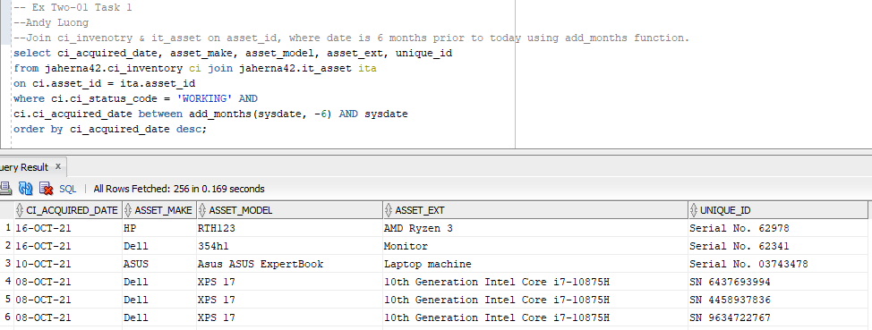

Task 2

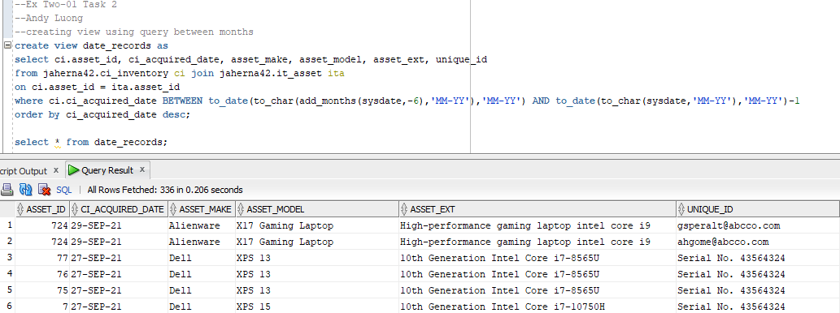

Task 3

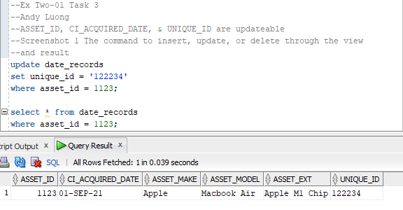

Task 4

--Ex Two-01 Task 4

--Andy Luong

--(a)

Add a state column field to the employee table, so the company has information

on where the employees stay.

--(b)

alter table jaherna42.employee

add STATE varchar2(100) NOT NULL

constraint df_state default 'TEXAS';

--Do not run the command. You do not have privileges to alter

--jaherna42's schema.

--(c)

insert into jaherna42.employee (STATE)

values ('');

select * from jaherna42.employee;

--You do not have to run the commands.

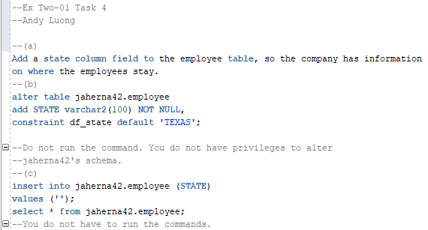

Task 5

--Ex Two-01 Task 5

--Andy Luong

--(a)

Add an age column field to employees table to check if person

is older than 18. You have to be at least 18 to work at this company.

--(b)

alter table jaherna42.employee

add AGE int,

constraint chk_age check (Age >= 18);

--Do not run the command. You do not have privileges to alter

--jaherna42's schema.

--(c)

insert into jaherna42.employee (AGE)

values (16);

insert into jaherna42.employee (AGE)

values (24);

--You do not have to run the commands.

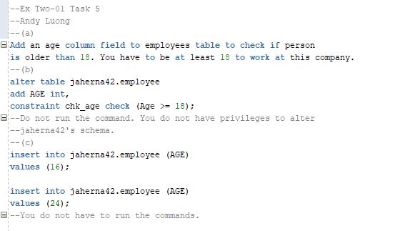

Bonus Task 6

